Diocese of Winona-Rochester
Circle of Grace Program for Children & Youth
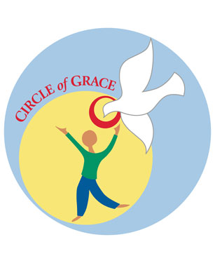
As part of the Diocese of Winona-Rochester's on-going commitment to implement the United States Bishops' Charter for the Protection of Children and Young People, I hereby formally promulgate the Circle of Grace Program as our Safe Environment Program to educate children in our schools and Faith Formation Programs.
Most Rev. John M. Quinn
Bishop of the Diocese of Winona-Rochester

Circle of Grace is a safe environment program developed by the Archdiocese of Omaha in response to Article 12 of the Charter for the Protection of Children and Young People. It serves the dual purpose of educating and forming youth about the value of positive relationships with God and others.
Through the Circle of Grace program, adults assist children and youth to recognize that each of us lives within a Circle of Grace that holds our very essence in body, mind, heart, soul, and sexuality. Through the Circle of Grace program, children and youth are taught to identify and maintain appropriate physical, emotional, spiritual and sexual boundaries; recognize when boundary violations are about to occur; and demonstrate how to take action when boundaries are threatened or violated.
Circle of Grace is clinically sound and grounded in the Catholic tradition. Its strong parent component means parents can actively participate in their children’s education and formation.
_________________________________________________________________________________________________________

Circle of Grace program:

I confirm that I have taught the Circle of Grace Program to my child ________________ ___ __________________________
(Child’s name)

_____________________________________________________________ (Please return this form to your Church or School)
Name of Parish/School

Parent’s name (printed):
Parent’s Signature:
Date:

_______________________________________ _________________________
Received by (For Office Use only) Date materials sent home

